

2012 Core-to-Core Program International Seminar
for Young Researchers



13th June 2012, 11:00-12:30
Room E204 (Exhibition Hall)
Pacifico Yokohama, Japan

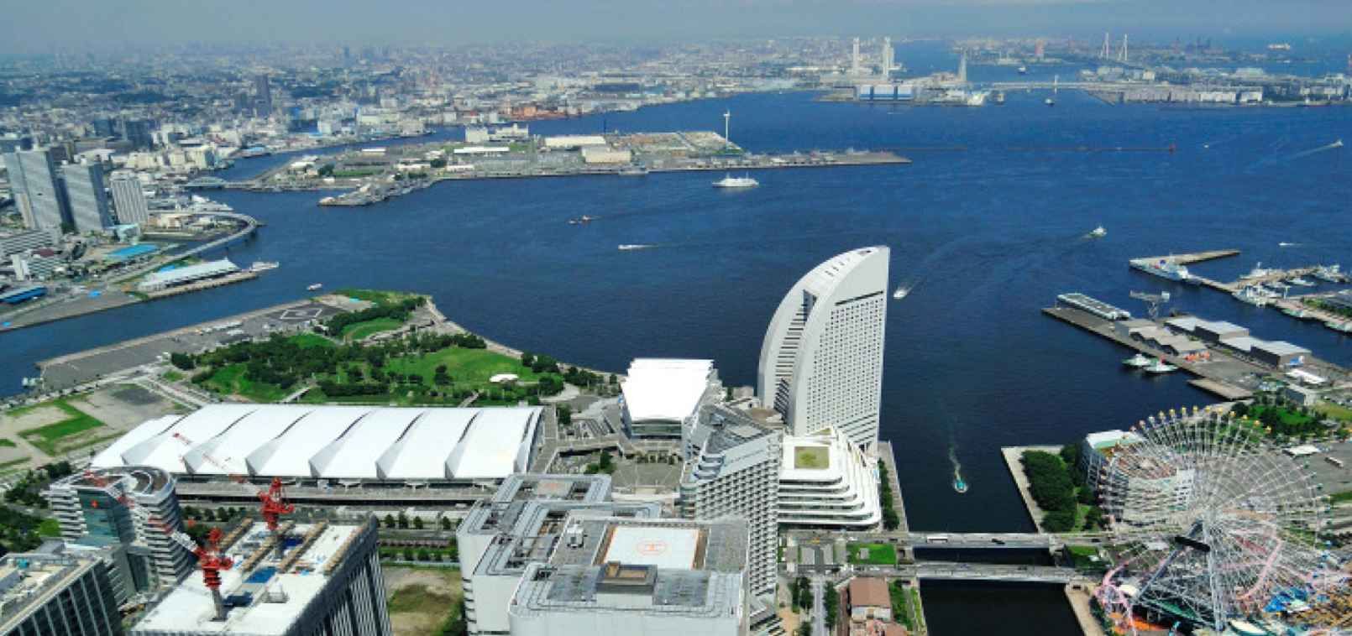
Greeting from Japanese coordinator

Dear Colleagues,

As the president of the 11th congress of Japanese Society for Regenerative Medicine, it is my great pleasure for me to hold this Educational Seminar for Young Researcher during this conference. The Core-to-Core Program between Finland, Germany, and Japan, has been started since 2009. Following to the previous meetings in Vienna, Geneva, Tampere, and Nagoya, at this seminar, I would like to exchange most recent results of our research works on myocardial regeneration using stem cells, and make fruitful discussion for the further development of new technologies and methods that open the doors for completely new possibilities of patient-specific treatment.
Cardiovascular and transplant surgery has changed dramatically in the past few years. The development of new technologies and methods has enabled huge advancements that open the doors for completely new possibilities of patient-specific treatment. Cardiac tissue engineering is one of the promising fields to be developed, and is expected to produce ideal materials for cardiovascular and transplant surgery. Our core institutions have developed unique technologies in this field, and some of them have been clinically applied. In our international consortium, we will unite and integrate our technologies and produce ideal materials for supplement cardiovascular defects or support cardiac function.
I hope this symposium makes great progresses for developing our international research consortium for myocardial regeneration and cardiac tissue engineering.

Yoshiki Sawa
Professor and Chairman
Department of Cardiovascular Surgery
Osaka University Graduate School of Medicine

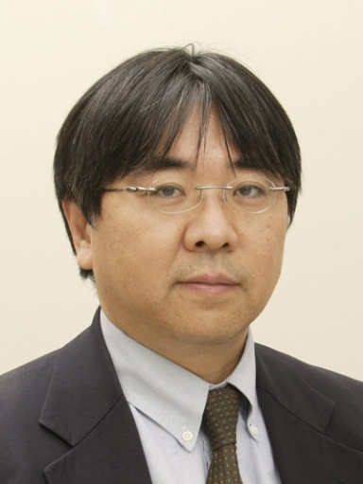
Program

Title: Myocardial regeneration using stem cells

Moderator:
Masamichi Ono Hannover Medical School
Satsuki Fukushima Osaka University

Commentator
Yoshinori Yoshida Kyoto University

Opening Remarks：11:00 - 11:05

Yoshiki Sawa: Osaka University

Session : 11:05 -12:25

1. Robert Zweigerdt: Hannover Medical School

2. Kenji Miki: Kyoto University

3. Masashi Kawamura: Osaka University

4. Antti Siltanen: Osaka University

5. Yukiko Imanishi: University of Helsinki

6. Tommi Pätilä: University of Helsinki

Closing Remarks：12:25 -12:30

Yoshiki Sawa: Osaka University

Abstract

1.
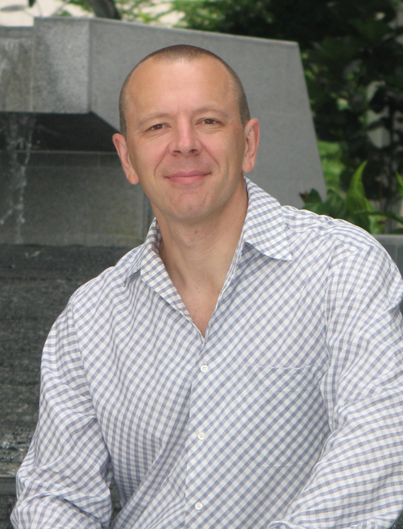
Robert Zweigerdt, PhD.

Principal Investigator,
Dept. of Cardiac, Thoracic,
Transplantation, and Vascular Surgery,
The Leibniz Research Laboratories for Biotechnology and Artificial Organs (LEBAO),
Hannover Medical School
Hannover, Germany

Towards human iPS Cells for heart repair: progress in cell production, genetic labeling and in vivo monitoring in a pig model.

Stem cell-based therapies are being actively explored as innovative therapeutic strategies for various genetic and acquired diseases. Recently, the possibility to reprogram human somatic cells into induced pluripotent stem cells (hiPSCs) that can be differentiated into all cell lineages present in the heart has opened novel opportunities for myocardial repair. However, there are major hurdles and risks to overcome regarding the envisioned pluripotent stem cell-based heart repair.
Towards this end, we have recently achieved major progress in several relevant areas which will be presented in this talk. These include the scalable hiPS cell production in controlled bioreactors, efficient multi-genetic modification of hiPSC and importantly the in vivo monitoring of human iPS cell grafts in a pig model of myocardial infarction.
This later technology relies on the expression of a transgenic sodium-iodide-symporter (NIS) in transplanted donor cells. The approach permits detection of viable transplanted cells by positron emission tomography (PET) or single photon emission computed tomography (SPECT) after iodide (123I) or 99mTc radiotracer administration and enabled us to detect hiPS cells in pig heart for up to 15 weeks after intramyocardial transplantation.

Contributing scientists: Christian Templin^{1,2}, MD; Robert Zweigerdt², PhD; Kristin Schwanke², PhD; Ruth Olmer², PhD; Jelena-Rima Ghadri³, MD; Maximilian Y. Emmert⁴, MD; Ennio Müller³; Silke M. Küest³, MD; Susan Cohrs⁵, PhD; Roger Schibli⁵, PhD; Peter Kronen^{6,7,8}, DVM; Monika Hilbe⁹, DVM; Andreas Reinisch¹⁰, MD, PhD; Dirk Strunk¹⁰, MD; Axel Haverich², MD; Simon Hoerstrup⁴, MD, PhD; Thomas F. Lüscher¹, MD; Philipp A. Kaufmann³, MD; Ulf Landmesser¹, MD; Ulrich Martin², PhD

¹Cardiovascular Center, Cardiology, University Hospital Zurich, Switzerland
²Leibniz Research Laboratories for Biotechnology and Artifical Organs, Cardiothoracic, Transplantation and Vascular Surgery, Hannover Medical School, Germany
³Cardiovascular Center, Cardiac Imaging, University Hospital Zurich, Switzerland
⁴Clinic for Cardiovascular Surgery, Department of Surgical Research, University Hospital Zurich, Switzerland
⁵Center for Radiopharmaceutical Science ETH-PSI-USZ, Paul Scherrer Institute, Villigen, Switzerland
⁶Veterinary Anaesthesia Services – International, Winterthur, Switzerland
⁷Center for Applied Biotechnology and Molecular Medicine (CABMM), Vetsuisse Faculty, University of Zurich, Switzerland
⁸Musculoskeletal Research Unit, Equine Department, Vetsuisse Faculty ZH, University of Zurich, Switzerland
⁹Institute of Veterinary Pathology, Vetsuisse Faculty ZH, University of Zurich, Switzerland
¹⁰Stem Cell Research Unit, Medical University of Graz, Austria.

2.
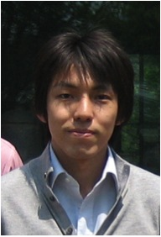

Kenji Miki, PhD.
Center for iPS Cell Research and Application
Kyoto University
Kyoto, Japan

Generation of highly-purified hiPSC derived cardiomyocyte sheets for clinical application

Background Human induced pluripotent stem cell (hiPSC)-derived cardiomyocytes hold significant promise for clinical applications. Widespread clinical application of hiPS cell-derived cells will require culture methods that are scalable and efficient method of differentiation into cardiomyocytes. However, most of protocols used a small-scale methods and fluorescence activated cell sorting (FACS) for purification of cardiomyocyte. In this study, we showed that a novel method of efficient and scalable differentiation of hiPSCs into cardiomyocytes and purification of them for clinical application.
Methods & Results Human iPS cell line 201B7 that was generated using the 4 transcription factors Oct4, Sox2, Klf4, and c-Myc (generous gift by Professor Yamanaka, Kyoto University, Japan) was used. The hiPSCs were floating-cultured and induced by Wnt/-catenin signaling molecules. At day 10, EBs were plated on gelatin-coated dishes and changed the medium every 2 days. The culture medium was subsequently replaced with no-glucose DMEM with 1 mM Lactic acid at day 20 and changed to 10% FBS/DMEM at the next day. At day 25, the culture medium was replaced with no-glucose DMEM with 1 mM Lactic acid again, and changed to 10% FBS/DMEM at the next day. To generate the hiPSC-derived cardiomyocyte (hiPSC-CM) sheet, The hiPS-CMs were detached and seeded onto 6 cm temperature-responsive cell culture dishs (UpCell) with human dermal fibroblasts. The next day, the dish was incubated at room temperature and the cells were spontaneously detached to form as a scaffold-free hiPS-CM sheet.
The hiPSC-CMs were highly positive for the cardiomyocyte-specific markers, such as cTNT(87.4±4.2%), α-actinin(89.7±3.8%) and Nkx2.5(84.2±4.3%). And our culture system of hiPS cells successfully yielded approximately 2.5×10⁷ hiPS-CMs. Subsequently, culture in the thermoresponsive dishes yielded scaffold-free hiPS-CM sheets in a round-shape. Hematoxylin&eosin(HE)-stained cross-sections of the sheet showed a 30-50 μm thick regular structure with abundant extracellular matrices. Immunohistolabeling showed that cTNT was homogeneously positive in the cytoplasm of the most of the cells in the hiPS-CM sheets.
Conclusion In present study, we could show that the novel culture system used yields a large number of highly purified hiPS-CMs.

3.
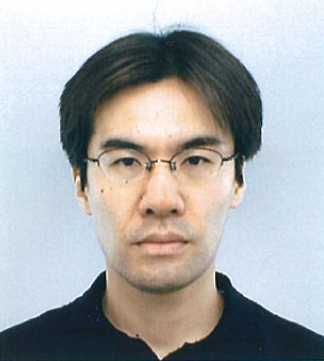

Masashi Kawamura, MD.
Dept. of Cardiovascular Surgery
Osaka University
Osaka, Japan

Human iPS Cell-Derived Cardiomyocyte Transplantation for Porcine Ischemic Cardiomyopathy by Using Cell-Sheet Technique

Introduction
Human iPS cell derived cardiomyocyte(hiPS-CM) is a promising cell source in regenerating myocardium. However, several issues need to be resolved before the clinical application of hiPS cells, in particular, the large-scale preparation of hiPS-CMs and the elimination of undifferentiated iPS cells. Cell-sheet technique have been developed as one of the best methods to transplant abundant cells. We hypothesized that hiPS-CM-sheet transplantation has feasibility, safety and therapeutic effectiveness in ischemic cardiomyopathy(ICM).

Methods & Results
Human iPS cells were established by introducing the retrovirus containing Oct3/4, Sox2, Klf4 and c-Myc into human dermal fibroblast. Treatment by WNT signaling molecules induced cardiomyogenic differentiation, yielding hiPS-CMs which showed alomost 90% positive for α-actinin, Nkx2.5 and cardiac troponin T. We created hiPS-CM sheets using thermoresponsive dishes. They were transplanted over the infarct myocardium of ICM model induced by placing ameroid constrictor on LAD in porcine (iPS group=6: sheet transplantation, Sham group=6: Both groups received tacrolimus daily). In the iPS group, cardiac performance was significantly better and left ventricular remodeling was significantly attenuated compared with the sham group. The hiPS-CMs were detected at 8 weeks after transplantation, but number of long-standing surviving hiPS-CMs was very small. Teratoma formation was not observed in animals that received hiPS-CM sheets.

Conclusions
The culture system used yields a large number of highly purified hiPS-CMs and hiPS-CM sheets could improve cardiac function in ischemic cardiomyopathy. This newly developed culture system and the hiPS-CM sheets may provide the basis for clinical application of hiPS cells in cardiac regeneration therapy.

4.
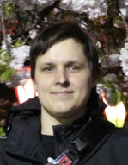
Antti Siltanen, PhD.
Exchanged Researcher,
Dept. of Cardiovascular Surgery
Osaka University
Osaka, Japan

Promotion of iPS cell differentiation to cardiomyocytes by laminins

The safe and effective clinical application of iPS cell-derived cardiomyocytes requires efficient differentiation protocol to accomplish high quantity and quality of cardiomyocytes. The current protocols, however, result in relatively low yield of differentiated cardiomyocytes predicting poor efficacy of therapy as well as increased safety risks.
Laminins are major proteins of the basal lamina that play important roles in several cellular processes including proliferation and differentiation. Effects of laminins are transmitted to cells by integrin-mediated signaling. Of the several laminin isoforms, laminin 211 is expressed in the heart and may play a role in cardiomyocyte differentiation. Another laminin 511 has been implicated in stem and progenitor cell proliferation.
The aim of this project is to study the ability of the cardiac specific laminin 211 to promote human ips cell differentiation to cardiomyocytes and the therapeutic potential of these cardiomyocytes after differentiation. Secondly, the ability laminin 511 to promote iPS cell-derived cardiomyocyte progenitor cell proliferation will be evaluated.
Differentiation of ips cells to cardiomyocytes will be done in vitro on laminin-coated cell culture dishes. Differentiation is detected by quantitating contracting cells as well as measuring expression of cardiac specific markers nkx2.5, gata4, connexin-43, and MHC by western blotting and RT-PCR. Progenitor cell expansion will be determined by CCK proliferation assay and FACS. Further, maturation stage of the cardiomyocytes is evaluated by immunofluorescence imaging of structural proteins as well as electron microscopy. The established differentiation protocol will be used to produce cardiomyocyte cell sheets with UpCell dishes and the therapeutic efficacy will be determined in porcine ischemic cardiomyopathy model. Cardiac function will be determined with echocardiography and histology will be used to determine graft survival and integration following transplantation.

5.
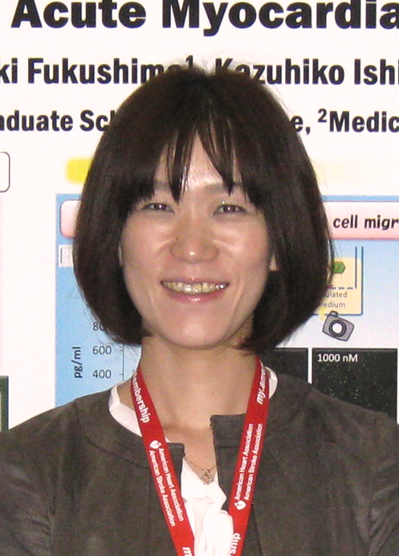

Yukiko Imanishi, PhD.

Exchanged Researcher,
Dept. of Cardiothoracic Surgery
University of Helsinki
Helsinki, Finland

Cellular-based immune suppression in the allogenic skeletal myoblast sheet transplantation

Introduction
In the clinical study, we have proved that transplantation of autologous skeletal myoblast (SMB) sheet onto the heart is effective and safe for ischemic cardiomyopathy, whereas this method still has limitation for use in the emergency case. Transplantation of allogenic, instead of autologous, SMB sheet will be an optimized cell therapy for cardiac injury. Immunorejection, however, is a major hurdle for allo-SMB therapy. Recently, mesenchymal stem cell (MSC) is reported to have immune-suppressive activity. MSCs do not express co-stimulatory signal molecules which are needed for T cell activation. Furthermore, MSCs secrete anti-inflammatory cytokines such as induced nitric oxide synthase (iNOS). We hypothesized that by blending MSCs with allogenic SMB-sheets, the immune responses induced by allogenic SMB-sheet transplantation are reduced, thereby resulting in the attenuation of cardiac dysfunction after MI.
Methods and Results
Western blotting analysis revealed that MSC expressed iNOS by stimulating with interferon gamma, lipopolysaccharide, and tumor necrosis factor alpha (TNF-α). To evaluate sheet survival in vivo, cell sheets consisting of luciferase-expressing SMB and MSC (hybrid sheet) were transplanted subcutaneously to Wistar rats. For control, cell sheets consisting of 100 % SMB were transplanted. We followed sheet survival for 2 weeks with in vivo bioluminescence imaging. Bioluminescence imaging revealed that SMB sheets diminished by 10 days, otherwise, hybrid sheets survived for 10 days.
Conclusion
Our data suggested that MSC probably prolong donor SMB survival in allogenic setting. Now we are conducting hybrid sheet transplantation using rat acute myocardial infarct model to evaluate the therapeutic efficacy for heart failure.
6.
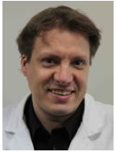

Tommi Pätilä, MD, PhD.
Staff Surgeon, Meilahti Hospital
Dept. of Cardiothoracic Surgery
University of Helsinki
Helsinki, Finland

A Need for New Blood Vessels in Cell Therapy of Heart

New strategies for end-stage heart failure are under development including cell therapy and angiogenic gene therapy. These methods have shown promise in the improvement of left ventricular function, by tissue regeneration or possibly solely by providing better distribution of blood in coronary bed. However, there is a fundamental problem of poor blood supply by conduit coronaries in end-stage coronary disease. To solve this problem in we have awakened the old Vineberg procedure, which has been disregarded since the evolution of direct coronary revascularization techniques. In the Vineberg procedure, left internal mammary artery (LIMA) is anastomosed directly to myocardium. LIMA anatomosed to a dead end in myocardium demonstrates remarkable characteristics against modern vascular surgical belief, not only by staying patent, but by arousing de novo arteriogenesis to connect itself to the surrounding coronary vasculature. Whilst previously the patency of the Vineberg anastomosis has been shown in ischemic myocardium of large animals and humans, we have shown for the first time the function of the graft in non-ischemic heart. This forgotten procedure offers several advantages to the field of therapeutic angiogenesis. The graft provides extra-cardiac blood supply to heart and it can be combined with all the other novel methods including cell therapy.
LIMA anastomosis to a non-ischemic heart offers an indispensable large animal model to the therapeutic angiogenesis studies. Furthermore, this model finishes the discussion whether de novo arteriogenesis exists. The aim of this presentation is to discuss the effectiveness of the Vineberg procedure in the setting of a single procedure or combined with cell transplantation wit cell sheet technology. We show results of porcine model as a large animal for preclinical studies and reveal results of our ongoing study with a rat model for screening the combined effects with cell sheet therapy.
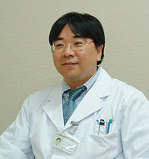
Moderator

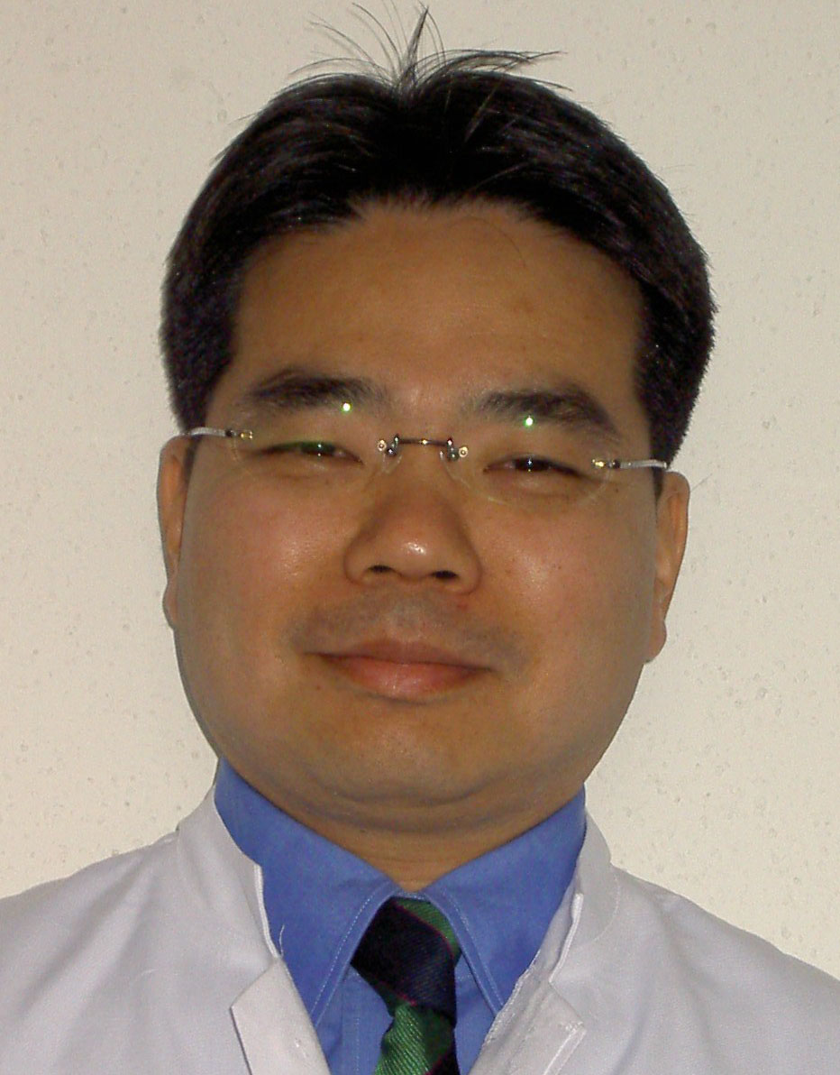
Masamichi Ono, MD, PhD.
Staff Surgeon, Pediatric Cardiac Surgery,
Dept. of Cardiac, Thoracic, Transplantation,
and Vascular Surgery
Hannover Medical School
Hannover, Germany

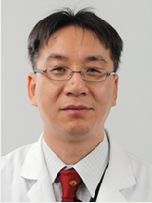
Satsuki Fukushima, MD, PhD.
Assistant Professor,
Dept. of Cardiovascular Surgery
Osaka University
Osaka Japan,

Commentator

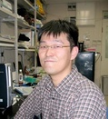
Yoshinori Yoshida, MD, PhD.
Assistant Professor,
Center for iPS Cell Research and Application
Kyoto University
Kyoto, Japan

Core Institution Address

Dept. of Cardiovascular Surgery
Osaka University Graduate School of Medicine
Yamada-oka 2-2, Suita, 565 0871, Osaka, Japan
Telefon: 81-6-6879-3154
Miss. Atsuko Shimai

Dept. of Cardiac, Thoracic, Transplantation and Vascular Surgery
Hannover Medical School
Carl-Neuberg Stra.1, 30625 Hannover, Germany
Telefon: 49-511-532-9397
Masamichi Ono. MD.
E-Mail: ono.masamichi@mh-hannover.de

Dept. of Cardiothoracic Surgery
University of Helsinki, Meilahti Hospital
Haartmaninkatu 4, 00029, Helsinki, Finland
Telefon: 358-9-4717-2305
Mrs. Kaisu-Maarit Pelkonen

Please refer to the following web site

http://jsps-osaka-u.jpn.org/



